

# Ed-Fi ODS API Overview for SIS Vendor and District

**Minnesota Department of Education Automated Student Data Collection System for School Year 2025-2026**

Revision Date: February 19, 2025

**Contents**

Change Log 2

Overview 4

Upgrade to Ed-Fi v6.2 for SY 2025-2026 4

SIS Vendor Certification Requirements for MDE’s Ed-Fi System 4

Preparation for Joint Powers SIS Vendor Certification 5

Reminders 5

Production Ed-Fi Key & Secret Update Process 5

Update Your Ed-Fi Descriptors Annually 5

Documentation Conventions 5

MDE Ed-Fi Test Sandbox Certification Testing 5

Ed-Fi Test Sandbox Administration Portal 6

Ed-Fi Swagger Interface 6

Ed-Fi Test Sandbox API URLs 6

Ed-Fi API Extension URLs 7

Ed-Fi API Core URLs 7

URLs in Test Sandbox vs. Production Environments 7

Ed-FI API Authentication (OAuth) URL 7

Minimal vs. Populated Test Sandbox ODS Databases 7

Other Ed-Fi Test Sandbox Environment Helpful Tips 8

MDE Ed-Fi API Documentation 8

Browsing MDE’s Ed-Fi API Using the Ed-Fi Swagger Tool 8

Mapping Documentation 10

Ed-Fi Descriptor References 10

MDE Identifiers 11

Ed-Fi Model Dependency 12

Read-Only Ed-Fi API Endpoints 12

Resource: /ed-fi/localEducationAgencies 12

Resource: /ed-fi/schools 12

Resource: /ed-fi/postSecondaryInstitutions 12

Resource: /ed-fi/programs 12

Resource: /ed-fi/courses 13

Resource: /ed-fi/staffs 13

## 

## Change Log

| Version | Date | Description of Changes |
| --- | --- | --- |
| v1.0 | 5/1/2024 | Initial version for the SY 2024-25 collection. This draft is an updated revision of the Ed-Fi ODS API Overview document from the SY 2023-24 collection. |
| v1.1 | 2/19/2025 | Updated revision for the SY 2025-2026 collection using Ed-Fi v6.2 in Azure. |

## Overview

Student Information Systems (SIS) vendors integrating with the Minnesota Department of Education (MDE) Ed-Fi Automated Student Data Collection system are required to pass SIS Vendor Certification testing prior to being granted a district's API key and secret to the production environment.

For SIS Vendor Certification testing, vendors are required to demonstrate their ability to submit data via specific API resources and elements encompassed within the various MDE data collection requirements. This testing is executed in the MDE Ed-Fi Test Sandbox environment.

Important notes about the MDE Ed-Fi Test Sandbox environment:

* The Test Sandbox environment does not include integration with the *Identities API* endpoint, meaning student identity is not validated on student records posted to a Test Sandbox.
* Ed-Fi API profiles are not enforced in the Test Sandbox environment. However, you may be required to demonstrate appropriate implementation of Ed-Fi API profile use in your API transactions.

When all scenarios are verified in the MDE Ed-Fi Test Sandbox environment, the SIS vendor is approved to release their code to their LEA customers for syncing student data to MDE’s Ed-Fi Automated Student Data Collection System for this school year.

### Upgrade to Ed-Fi v6.2 for SY 2025-2026

MDE has upgraded to Ed-Fi version 6.2 for the 2025-2026 school year. This upgrade also moves MDE’s Ed-Fi system to cloud hosting in Microsoft Azure. This upgrade required system architecture changes that resulted in a new URL format for MDE Ed-Fi system components for the 2025-2026 school year. **Please use the new URL format for connecting to MDE’s Ed-Fi API for the 2025-2026 school year.**

Note that MDE will continue to use the current Ed-Fi version 5.2 environment for the remainder of the 2024-2025 data collection. The URLs for the Ed-Fi version 5.2 environment are unchanged.

### SIS Vendor Certification Requirements for MDE’s Ed-Fi System

MDE will use the following staged SIS Vendor Certification process for MDE’s Ed-Fi system for SY 2025-2026.

**Stage 1:** Demonstrate SIS ability to send data and delete data using MDE’s Ed-Fi ODS/API.

**Stage 2:** Minnesota customers must receive the SIS software updates for 2025-2026 by the specified deadline. Also provide MDE with the customer training plan on the SIS software updates.

An overview of these stages is below.

| Milestone | Deadline |
| --- | --- |
| SIS Vendor questions due regarding the 2025-2026 certification process | March 14, 2025 |
| Stage 1 certification due | June 30, 2025 |
| Stage 2 certification due | July 25, 2025 |

The Stage 2 due date is also the deadline when Minnesota customers must receive the SIS software updates for SY 2025-2026.

#### Preparation for Joint Powers SIS Vendor Certification

In MDE’s SIS vendor certification process, the SIS vendor typically creates a test sandbox ahead of the certification meeting. The SIS vendor communications the test sandbox key to MDE and MNIT at the beginning of the certification meeting for accessing the Ed-Fi ODS database and validating data sync results.

For Joint Powers SIS Vendor Certification, MDE will use a new end-to-end testing process which allows MDE and MNIT to see how the data sync from the SIS vendor is translated by MDE’s Ed-Fi data pipeline for MARSS and validate the end results. To support this testing process, **SIS vendors must communicate the test sandbox key at least one day before the certification meeting** to allow the end-to-end test environment to be configured ahead of time.

### Reminders

#### Production Ed-Fi Key & Secret Update Process

MDE’s process to provide updated production keys & secrets migrates LEA keys and secrets from the prior year with the year suffix on the Ed-Fi API key. We will be using the same process for SY 2025-2026, incrementing the Ed-Fi API key suffix to ‘2026’.

#### Update Your Ed-Fi Descriptors Annually

Whenever possible, MDE schedules updates to Ed-Fi descriptor values at the beginning of each new school year rather than mid-year updates. SIS vendors should annually update their Ed-Fi descriptor tables before the beginning of each school year.

### Documentation Conventions

URLs in this document might not be active at first, and will then be marked with:

Not currently active

These URLs are also subject to change upon actual Ed-Fi implementation for the 2025-2026 school year.

## MDE Ed-Fi Test Sandbox Certification Testing

See [MDE’s Ed-Fi Documentation GitHub site](https://github.com/mn-mde-edfi/MDE-EdFi-Documentation/) for the [Test Sandbox Certification Scenarios](https://github.com/mn-mde-edfi/MDE-EdFi-Documentation/blob/master/sandbox_cert_a_toc.md) and [SIS Vendor and District Test Plan](https://github.com/mn-mde-edfi/MDE-EdFi-Documentation/blob/master/sis_test_plan_a_toc.md).

When certification begins, vendors will be required to generate a key and secret to a sandbox ODS/API with no sample data pre-loaded. This ODS will contain the MDE School and Local Education Agency (LEA) records synchronized with MDE-ORG, MDE-specific descriptors, LEA Programs, and the State Course Catalog and Staff records required for the Minnesota Common Course Catalog (MCCC) data collection. When submitting data for each of the SIS Vendor Certification scenarios, we ask that you use a district you serve and schools within that district.

### Ed-Fi Test Sandbox Administration Portal

[MDE Sandbox Administration Site](https://test.pub.education.mn.gov/edfisbadmin/)

As part of Sandbox certification, you will need access to the Ed-Fi Test Sandbox Administration Portal. To request an account, [contact MDE by email](mailto:EdFiProjectSupportMNIT.MDE@state.mn.us). In the Sandbox Admin Site, you will be able to create ODS database instances to use for development and testing of your integrations.

(See the [Ed-Fi TechDocs Website](https://edfi.atlassian.net/wiki/spaces/ODSAPIS3V62/pages/18219467/Using+the+Sandbox+Administration+Portal)for more detailed instructions on using the Ed-Fi Test Sandbox Administration Portal.)

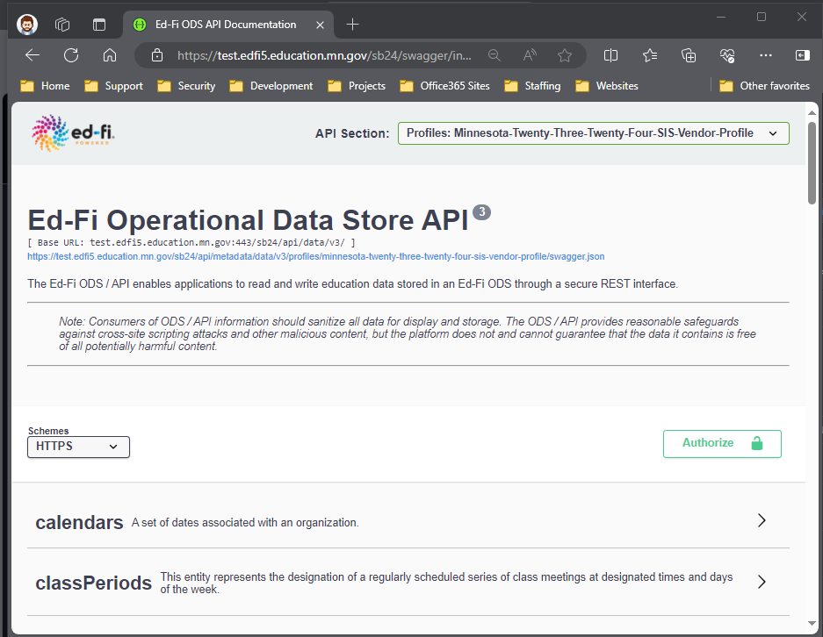

**Ed-Fi API Profile Selector**

### Ed-Fi Swagger Interface

[Swagger Interface](https://test.pub.education.mn.gov/edfiswag/)

Use the Ed-Fi Swagger interface to visualize and interact with MDE’s Ed-Fi API. Developers can access this user interface to test-drive Create, Read, Update, and Delete (CRUD) actions using MDE’s Ed-Fi API before building integrations as necessary.

All MDE-specific Ed-Fi API resources can be found under the Ed-Fi API profiles for each school year:

* Minnesota-Twenty-Four-Twenty-**Five**-SISVendor-Profile *for data submitted to the school year 2024-****2025*** *ODS*
* Minnesota-Twenty-Five-Twenty-**Six**-SISVendor-Profile *for data submitted to the school year 2025-****2026*** *ODS*

*Note: The Ed-Fi Identities API documentation is not available the Ed-Fi Swagger tool in the Ed-Fi Test Sandbox environment.*

### Ed-Fi Test Sandbox API URLs

**NOTE:** This section documents the new URL format for MDE Ed-Fi system components for the 2025-2026 school year. **Please use the new URL format for connecting to MDE’s Ed-Fi API for the 2025-2026 school year.**

Developers can test their code integrations with MDE’s Ed-Fi API in the Ed-Fi Test Sandbox environment using the URLs in this section. (Use HTTPS before each when configuring API actions.)

* The Ed-Fi API base URL is: test.api.education.mn.gov/edfiapi/
* The Data Management base URL is: test.api.education.mn.gov/edfiapi/data/v3

Please note details on how this URL changes for addressing MDE API extension vs. Ed-Fi API core resources.

#### Ed-Fi API Extension URLs

The URL for addressing MDE’s Ed-Fi API extension resources should include ‘MN’ after ‘v3’. For example, when addressing the *studentSection504PlanProgramAssociations* resource, the URL is:

…/edfiapi/data/v3/**MN**/studentSection504PlanProgramAssociations

#### Ed-Fi API Core URLs

The URL for addressing Ed-Fi API core resources should include ‘ed-fi’ after ‘v3’. For example, when addressing the *StudentSchoolAssociation* resource, the URL is:

…/edfiapi/data/v3/**ed-fi**/studentSchoolAssociations

#### URLs in Test Sandbox vs. Production Environments

In the QA, Staging, and Production environments,the school year must be included after “/v3/” and before the core/extension namespace as shown below:

* Ed-Fi API Core URL: …/edfiapi/data/v3/**2025**/ed-fi/studentSchoolAssociations
* Ed-Fi API Extension URL: …/edfiapi/data/v3/**2025**/MN/studentSection504PlanProgramAssociations

**Do not include the school year this way in the URLs for the Ed-Fi Test Sandbox environment.**

#### Ed-FI API Authentication (OAuth) URL

The Ed-Fi API authentication URL is: test.api.education.mn.gov/edfiapi/oauth

Authentication in Ed-Fi Suite 3 ODS/API uses two-legged OAuth 2.0 Client Credentials Grant Flow. More information and sample API calls are located on the [Ed-Fi TechDocs Website](https://edfi.atlassian.net/wiki/spaces/ODSAPIS3V62/pages/18219440/Authentication).

### Minimal vs. Populated Test Sandbox ODS Databases

When creating a sandbox, you have the “populated” option of including a set of sample data in the sandbox. The sample database template is associated with St. Paul Public School District (LocalEducationAgencyId = 10625000). When you do not select the “populated” option to include sample data, your sandbox database will be loaded with an empty (“minimal”) ODS, except that it includes required data such as:

* Minnesota schools, districts, and other education organizations (from MDE-ORG)
* Descriptors customized for MDE’s Ed-Fi ODS/API
* Minnesota district programs for each program type
* Minnesota state course codes for Minnesota Common Course Catalog

*NOTE: Due to the limited usefulness of the “populated” data set, the populated database template is no longer maintained but is still available as an option for creating test sandbox Ed-Fi ODS databases.*

The actual SIS vendor certification test will be conducted in a “minimal” sandbox with no sample data loaded. SIS vendors will reference their own data in the test scenarios, relating elements to MDE schools, districts, and descriptors as needed.

### Other Ed-Fi Test Sandbox Environment Helpful Tips

* In the Staging and Production environments, SIS vendor API keys will be associated with a claim set limiting access to only the API resources included in this document. This claim set has been enabled in the Sandbox environment. When you access a resource not included in the claim set, you will receive the following message in the response:

*"Access to the resource could not be authorized. Are you missing a claim?”*

* A SIS Vendor profile has been created limiting access to specific properties on each of the resources required in each school year. Profiles are tied to your key and secret and are auto-enabled in Staging and Production. This means that you will not have to include the profile in the “accept” or “content-type” headers of the request for the profile to take effect.

## MDE Ed-Fi API Documentation

### Browsing MDE’s Ed-Fi API Using the Ed-Fi Swagger Tool

For each of the resources described in this document, the elements/properties required are included and browsable in the Ed-Fi Swagger Tool ("Swagger") under the current profile.

For example, to view required properties for the *studentSchoolAssociations* resource, open the "POST" action in Swagger:

POST /ed-fi/studentSchoolAssociations: Creates or updates resources based on the natural key values of the supplied resource.

*Note:* "ed-fi" in the path above indicates that this is a core resource.

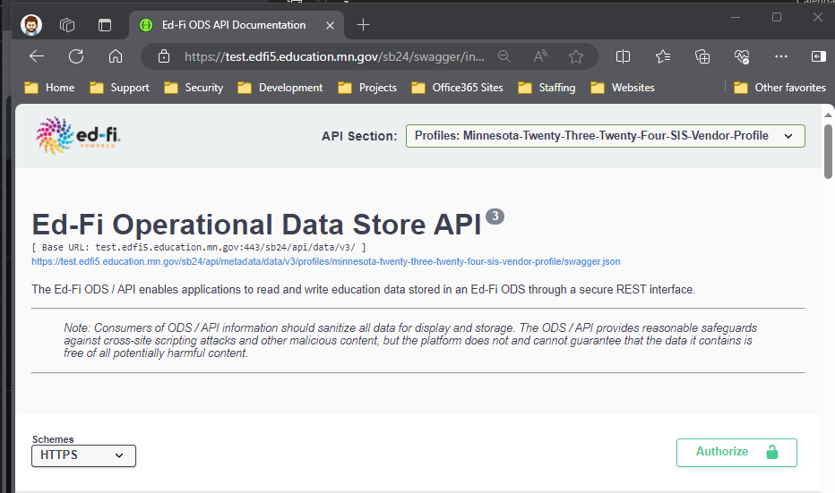

**Select Ed-Fi API Profile**

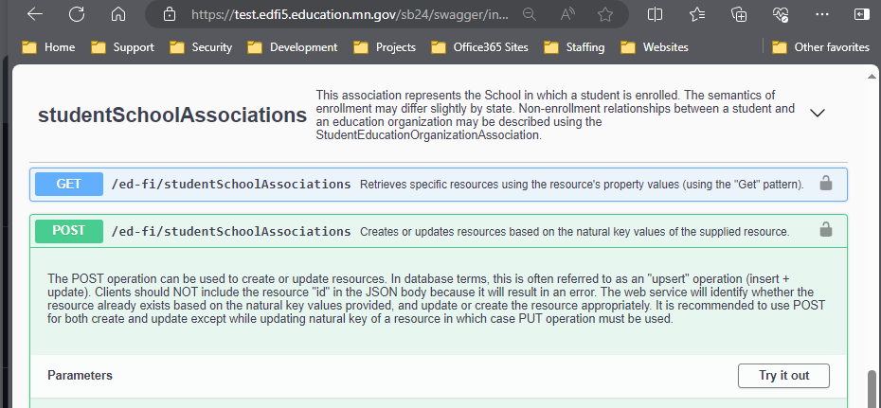

**Scroll to find and expand the desired resource**

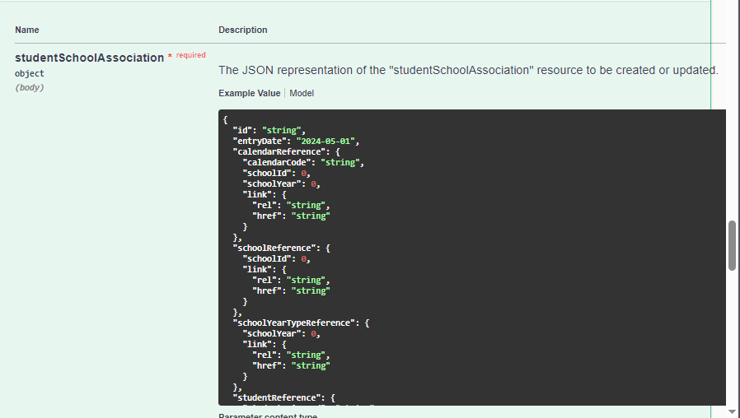

**Select “Example Value” to view the resource properties as a sample JSON object template**

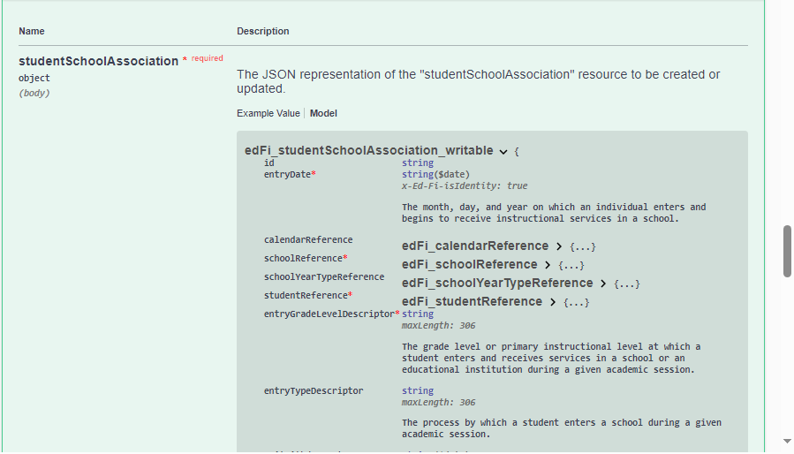

**Select “Model” to view the resource property definitions and data types. Required properties are marked with a red asterisk.**

Often, the actual data posting for an individual record can be much less than what is in the model. For example, compare the Swagger resource property sample below for a *localEducationAgencyId* reference with an actual JSON excerpt.

Swagger documentation excerpt:

"residentLocalEducationAgencyReference": {

"localEducationAgencyId": 0,

"link": {

"rel": “string”,

"href": “string”,

},

},

Actual JSON excerpt:

"residentLocalEducationAgencyReference": {

"localEducationAgencyId": 10625000

},

### Mapping Documentation

See the Data Mapping Matrix spreadsheets in the “{YYYY-YY} MDE Ed-Fi Documentation” folders on [MDE’s Ed-Fi Documentation GitHub site](https://github.com/mn-mde-edfi/MDE-EdFi-Documentation/). These spreadsheets show how each data collection maps to the Ed-Fi Data Standard. Each school year's Data Mapping Matrix spreadsheet includes the mappings between MDE elements and Ed-Fi core and extension entities and elements.

### Ed-Fi Descriptor References

See [MDE’s Ed-Fi Documentation GitHub site](https://github.com/mn-mde-edfi/MDE-EdFi-Documentation/) for the list of [MDE Ed-Fi API Descriptor Tables](https://github.com/mn-mde-edfi/MDE-EdFi-Documentation/blob/master/descriptorTables/AboutDescriptorTables.md) and additional documentation on [Descriptors and Resources](https://github.com/mn-mde-edfi/MDE-EdFi-Documentation/blob/master/descriptors_resources.md). In the Ed-Fi Swagger Tool, you can access the descriptor list by selecting “Descriptors” from the Ed-Fi API Profiles Selector.

MDE’s custom descriptor codes have been loaded under the namespace "uri://education.mn.gov/”. However, MDE does also use some default Ed-Fi descriptor codes with the namespace “uri://ed-fi.org/”. Check the descriptor tables for the correct descriptor namespace.

All descriptor references require namespaces and do not rely on the concept of a default operational context. Descriptor references must be formatted as follows:

uri://[organization indicator]/[name of descriptor]#[code value]

For example, below is a reference to the “Special Education” code value for the ProgramType descriptor:

uri://education.mn.gov/ProgramTypeDescriptor#Special Education

The following JSON excerpt is from the Minnesota extension of the *studentSchoolAssociations* resource. Note the usage of the *membershipAttendanceUnitDescriptor* and the *transportationCategoryDescriptor*.

"_ext": {

"MN": {

"homeboundServiceIndicator": true,

"specialPupilIndicator": true,

"residentLocalEducationAgencyReference": {

"localEducationAgencyId": 10625000

},

"membership": {

"membershipAttendanceUnitDescriptor": "uri://education.mn.gov/MembershipAttendanceUnitDescriptor#Days",

"attendance": 180,

"membership": 180,

"percentEnrolled": 100

},

"transportation": {

"transportationCategoryDescriptor": "uri://education.mn.gov/TransportationCategoryDescriptor#01",

"transportingLocalEducationAgencyReference": {

"localEducationAgencyId": 10625000

}

}

}

}

### MDE Identifiers

| Ed-Fi Identifier Name | MDE Identifier Name & Source System | Additional Information |
| --- | --- | --- |
| StudentUniqueId | State Student ID  (Student ID System),  MARSS Number (MARSSWES) | See [Ed-Fi Identities API](https://github.com/mn-mde-edfi/MDE-EdFi-Documentation/blob/master/sis_test_plan_d_staging.md#ed-fi--marss-identities-api-integrations) for documentation on integration with MDE’s Student ID System to create new state student IDs. |
| EducationOrganizationId, LocalEducationAgencyId, SchoolId, PostSecondaryInstitutionId, StateEducationAgencyId | State Organization ID (MDE Organization Reference Glossary) | See [MDE’s Ed-Fi Documentation GitHub site](https://github.com/mn-mde-edfi/MDE-EdFi-Documentation/) for documentation on [Minnesota District and School IDs](https://github.com/mn-mde-edfi/MDE-EdFi-Documentation/blob/master/sis_test_plan_b_cert_testing.md#minnesota-district-and-school-ids).  More information is available in [MDE-ORG](https://public.education.mn.gov/MdeOrgView/), including this reference on [LEA (organization) types](https://public.education.mn.gov/MdeOrgView/reference/orgTypes). |
| StaffUniqueId | File Folder Number / FFN (Educator Licensing System) |  |

See [MDE’s Ed-Fi Documentation GitHub site](https://github.com/mn-mde-edfi/MDE-EdFi-Documentation/) for the MDE Ed-Fi API requirements for [EducationOrganizationId Usage by Resource](https://github.com/mn-mde-edfi/MDE-EdFi-Documentation/blob/master/sis_test_plan_c_data_reqs.md#education-organization-id-usage-by-resource).

### Ed-Fi Model Dependency

Ed-Fi uses a data-dependency security model that enforces the order of creation when inserting various records via the API. This is often encountered via API errors such as the following:

*Authorization denied. The claim does not have any established relationships with the requested resource.*

See [MDE’s Ed-Fi Documentation GitHub site](https://github.com/mn-mde-edfi/MDE-EdFi-Documentation/) for [Ed-Fi Model Dependency Graphs](https://github.com/mn-mde-edfi/MDE-EdFi-Documentation/blob/master/sis_test_plan_c_data_reqs.md#ed-fi-model-dependency) demonstrating the dependencies of various data resources in MDE’s Ed-Fi API.

### Read-Only Ed-Fi API Endpoints

Several of the required Ed-Fi API data elements are loaded by MDE into the Ed-Fi ODS and are read-only to the SIS Vendor API profiles. This section details those elements.

#### Resource: /ed-fi/localEducationAgencies

This entity represents an administrative unit at the local level which exists primarily to operate schools or to contract for educational services. It includes school districts, charter schools, or other local administrative organizations.

All local education agency organization data required for Ed-Fi is loaded into the ODS from MDE-ORG.

#### Resource: /ed-fi/schools

This entity represents an educational organization that includes staff and students who participate in classes and educational activity groups.

All school organization data required for Ed-Fi is loaded into the ODS from MDE-ORG.

#### Resource: /ed-fi/postSecondaryInstitutions

An organization that provides educational programs for individuals who have completed or otherwise left educational programs in secondary school(s).

All postsecondary institution organization data required for Ed-Fi is loaded into the ODS from MDE-ORG.

#### Resource: /ed-fi/programs

This entity represents any program designed to work in conjunction with, or as a supplement to, the main academic program. Programs may provide instruction, training, services, or benefits through federal, state, or local agencies. Programs may also include organized extracurricular activities for students.

Program data records are created for each appropriate program type, for each organization, as part of the organization data load into the ODS from MDE-ORG.

#### Resource: /ed-fi/courses

This educational entity represents the organization of subject matter and related learning experiences provided for the instruction of students on a regular or systematic basis.

The MCCC State Course Catalog courses are loaded for the state education agency (EducationOrganizationId = 999999000) into the ODS by MDE.

#### Resource: /ed-fi/staffs

This entity represents an individual who performs specified activities for any public or private education institution or agency that provides instructional and/or support services to students or staff at the early childhood level through high school completion.

Licensed educator records are loaded from the Educator Licensing system into the ODS by MDE for referencing in MCCC staffSectionAssociations.